Prayer Concerns

Carl and Betty Tate; Kim and Ann South; Walsh family; Vicky Hogge; Isla Escagne; Sue Bueakenkamp; Kathy Carraway; Fred & Jerry Dant; Sandy Springs, Emily Farmer’s friend; Betty Johnson; Marina Schofield; Jim and Sue Ann Salmon; Connie & Johnnie Robertson; Rev. Gary Livermon; Peggy Vaudt; Phil & Joyce Smith; Trisha, Wandra Thornton’s friend; Steve Davis; Teresa Keaton; Candi, Betty Ann Tabler’s niece; Chip Britzmayr; Fran Miller’s cousin; Ravyn, Bartz’ great-granddaughter; Betty Ann Tabler; all those recovering from covid

Calendar

Monday Church Council 7:00 p.m.
Tuesday Church Council 7:00 p.m.
Wednesday Lenten Study 2:00 p.m.
Thursday Chancel Choir 11:00 a.m.
Saturday Food Pantry 9-11 a.m.
Contemporary Worship 5:00 p.m.
Sunday Adult Sunday School 9:30 a.m.

Announcements

Food Pantry- We will be having our next Food Pantry on Saturday, April 22. We will be having it in the style of the Cryer Center mobile food pantry. We will need volunteers who can carry bags to the cars and a few other volunteers. If you can help, please contact Fran Miller.

We give a warm welcome to our guests today. Please stop by the fellowship hall for refreshments after church.

Financial Standings:
2023 Operating Budget $ 118,440.00
Received as of April 9: $ 34,068.82
Needed by end of April to stay on budget $ 5,411.18

Scripture for April 23:
Luke 24:13-35

Clarksbury
United Methodist Church

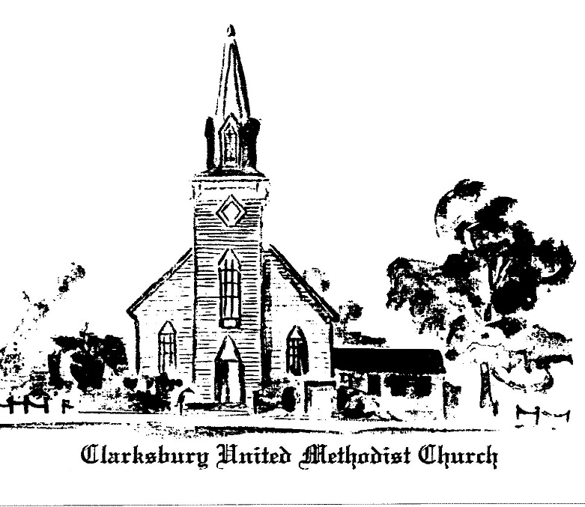,6
oooooooooooooooooooooooooooooooooooooo

15924 General Puller Hwy.
P.O. Box 10
Hardyville, VA 23070
(804) 776-6060
www.clarksburyumc.com

Our Mission
To receive and share God’s love through
worship, education, service, and outreach

April 16, 2023
2nd Sunday of Easter
(As we gather, let us do so in reverent silence.)

Chimes

Prelude Ann Thomas

Greeting & Announcements

Choral Introit Chancel Choir
“Worthy Is the Lamb” Stan Pethel

VCall to Worship: Psalm 16 UMH 748

VAffirmation of Faith UMH 885

VGloria Patri UMH 70

VHymn of Praise UMH 304
“Easter People, Raise Your Voices”
(Please pass your praise and concern cards to the ushers during the last verse.)

Prayer Concerns and Pastoral Prayer

The Lord’s Prayer

Special Music Millie Larrauri
"The God Who Sees" Kathie Lee Gifford & Nicole C. Mullen

New Testament Reading: Acts 2:14, 22-32 Page 119

Children’s Sermon

Sermon “We Are Witnesses” Pastor Ken

VHymn of Invitation UMH 312
“Hail the Day That Sees Him Rise”

Offering Becky Wilhite
“Brethren, We Have Met to Worship” arr. by Kenon D. Renfrow

Doxology UMH 95

Praise God, from whom all blessings flow;
praise Him, all creatures here below;
praise Him above, all heavenly host;
praise Father, Son, and Holy Ghost. Amen.

Offertory Prayer

VHymn of Dedication “He Lives” UMH 310

 Benediction

V Chimes

Postlude

V Please stand as you are able.

Church Copyright License ® A 21853196
Streaming Plus License ™ A 21853206

Scripture Reader/ Liturgist for April: Charlie Townes
Counters for April: Fran Miller & Dawn Wilt
Ushers for April: Ronnie & Cheryl Teagle

Pastor Ken Cleveland
776-1177 Home kencleveland@vaumc.org
(276) 224-4935 Cell
Ministers of Music Becky Wilhite, Ann Thomas
Nursery Kimberly South
Custodian Ilka Fernandez
Ministers People of Clarksbury

