Prayer Concerns

Carl and Betty Tate; Kim and Ann South; Vicky Hogge; Isla Escagne; Sue Bueakenkamp; Kathy Carraway; Fred & Jerry Dant; Sandy Springs, Emily Farmer’s friend; Betty Johnson; Marina Schofield; Jim and Sue Ann Salmon; Connie & Johnnie Robertson; Rev. Gary Livermon; Peggy Vaudt; Phil & Joyce Smith; Trisha, Wandra Thornton’s friend; Steve Davis; Teresa Keaton; Candi, Betty Ann Tabler’s niece; Chip Britzmayr; Fran Miller’s cousin; Betty Ann Tabler; Walsh family on death of grandmother; all those recovering from covid and other illnesses

Calendar

Tonight Gospel Sing 5:00 p.m.
Thursday Chancel Choir 11:00 a.m.
Saturday Contemporary Worship 5:00 p.m.
Sunday Adult Sunday School 9:30 a.m.

Announcements

Scholarship- It is that time of year again! If you have a family member continuing their higher education, they are eligible to receive the church’s scholarship. Applications are on the church website. Applications must be received by June 15.

We give a warm welcome to our guests today. Please stop by the fellowship hall for refreshments after church.

Financial Standings:
2023 Operating Budget $ 118,440.00
Received as of April 16: $ 37,425.82
Needed by end of April to stay on budget $ 2,054.18

Scripture for April 30:
1 Peter 2:19-25
Pastor Ken Cleveland
776-1177 Home kencleveland@vaumc.org
(276) 224-4935 Cell
Ministers of Music Becky Wilhite, Ann Thomas
Nursery Kimberly South
Custodian Ilka Fernandez
Ministers People of Clarksbury

Clarksbury
United Methodist Church

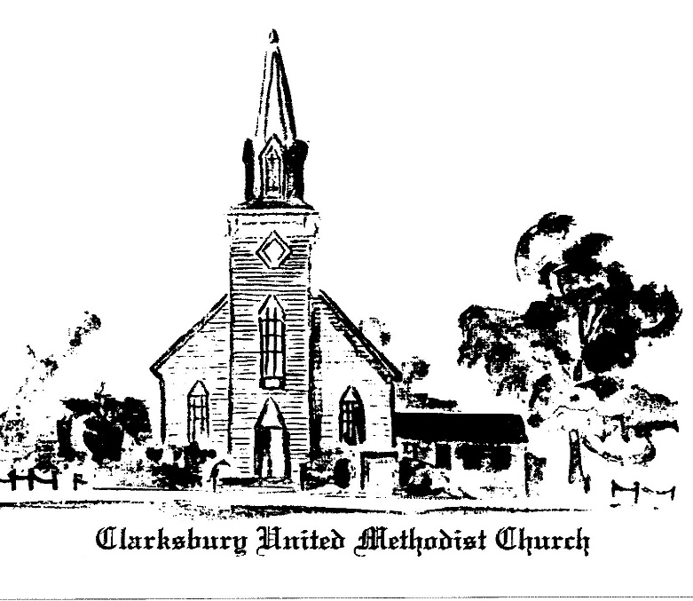,6
oooooooooooooooooooooooooooooooooooooo

15924 General Puller Hwy.
P.O. Box 10
Hardyville, VA 23070
(804) 776-6060
www.clarksburyumc.com

Our Mission
To receive and share God’s love through
worship, education, service, and outreach

April 23, 2023
3rd Sunday of Easter
(As we gather, let us do so in reverent silence.)

Chimes

Prelude Ann Thomas

Greeting & Announcements

VCall to Worship: Psalm 116:1-4, 12-19 UMH837

VAffirmation of Faith UMH 882

VGloria Patri UMH 70

VHymn of Praise “Christ Is Alive” UMH 318 (Please pass your praise and concern cards to the ushers during the last verse.)

Prayer Concerns and Pastoral Prayer

The Lord’s Prayer

Anthem Chancel Choir
"We Have Seen Him" Stan Pethel

New Testament Reading: Luke 24:13-35 Page 90

Children’s Sermon

Sermon “We've Seen the Lord” Pastor Ken

VHymn of Invitation UMH 454
“Open My Eyes, That I May See”

Offering

Doxology UMH 95

Praise God, from whom all blessings flow;
praise Him, all creatures here below;
praise Him above, all heavenly host;
praise Father, Son, and Holy Ghost. Amen.

Offertory Prayer

VHymn of Dedication “Where He Leads Me” UMH 338

 Benediction

 Choral Benediction UMH 349
“Turn Your Eyes Upon Jesus”
V Chimes

Postlude

V Please stand as you are able.

Church Copyright License ® A 21853196
Streaming Plus License ™ A 21853206

Scripture Reader/ Liturgist for April: Warren Wright
Counters for April: Fran Miller & Dawn Wilt
Ushers for April: Ronnie & Cheryl Teagle

