Prayer Concerns

Carl and Betty Tate; Kim and Ann South;; Isla Escagne; Sue Bueakenkamp; Kathy Carraway; Fred & Jerry Dant; Sandy Springs, Emily Farmer’s friend; Betty Johnson; Marina Schofield; Jim and Sue Ann Salmon; Connie & Johnnie Robertson; Rev. Gary Livermon; Peggy Vaudt; Phil & Joyce Smith; Trisha, Wandra Thornton’s friend; Steve Davis; Teresa Keaton; Candi, Betty Ann Tabler’s niece; Chip Britzmayr; Fran Miller’s cousin; Betty Ann Tabler; the family of Vicky Hogge; Garland Dobbins; all those recovering from covid and other illnesses

Calendar

Thursday Chancel Choir 11:00 a.m.
Saturday Contemporary Worship 5:00 p.m.
Sunday Adult Sunday School 9:30 a.m.

Announcements

The men of the church will host a Mother’s Day breakfast for ALL the ladies of the church on Saturday, May 13th at 9 a.m.

The Called Charge Conference for the disaffiliation vote will be held on Saturday, June 24th at 1 p.m. Please note, only professing members of Clarksbury UMC are eligible to vote and must be present at this meeting to vote. No proxies or absentee ballots.

Scholarship - It is that time of year again! If you have a family member continuing their higher education, they are eligible to receive the church’s scholarship. Applications are on the church website. Applications must be received by June 15.

We give a warm welcome to our guests today. Please stop by the fellowship hall for refreshments after church.

Financial Standings:
2023 Operating Budget $ 118,440.00
Received as of April 23: $ 39,941.82
Needed by end of April to stay on budget $ -461.82

Scripture for May 7:
Acts 7: 55-60

Clarksbury
United Methodist Church

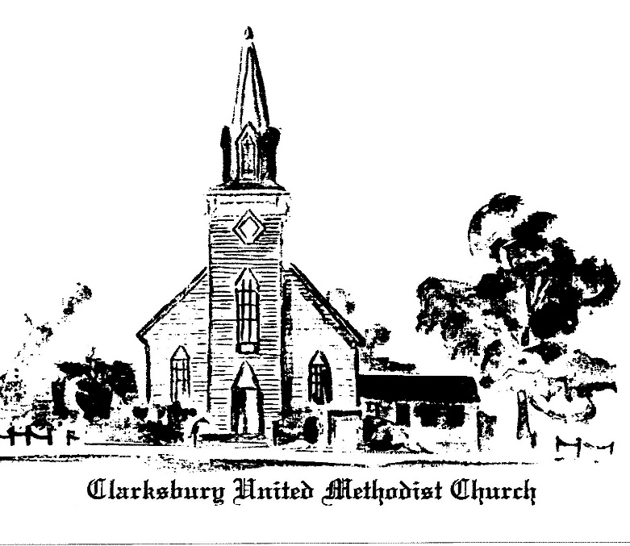,6
oooooooooooooooooooooooooooooooooooooo

15924 General Puller Hwy.
P.O. Box 10
Hardyville, VA 23070
(804) 776-6060
www.clarksburyumc.com

Our Mission
To receive and share God’s love through
worship, education, service, and outreach

April 30, 2023
4th Sunday of Easter
(As we gather, let us do so in reverent silence.)

Chimes

Prelude Ann Thomas
“Our Savior, Our Shepherd” arr. Sikes

Greeting & Announcements

VCall to Worship: Psalm 23 UMH134

VAffirmation of Faith: Wesleyan Covenant UMH 607

VGloria Patri UMH 70

VHymn of Praise UMH 381
“Savior, Like a Shepherd Lead Us”
(Please pass your praise and concern cards to the ushers during the last verse.)

Prayer Concerns and Pastoral Prayer

The Lord’s Prayer

Anthem Chancel Choir
"Wonderful, Merciful Savior” D. Rogers & E. Wyse

New Testament Reading: 1 Peter 2: 19-25 Page 233

Children’s Sermon

Sermon “He Bore OUR Sin!” Pastor Ken

VHymn of Invitation UMH 413
“A Charge to Keep I Have”

Offering

Doxology UMH 95

Praise God, from whom all blessings flow;
praise Him, all creatures here below;
praise Him above, all heavenly host;
praise Father, Son, and Holy Ghost. Amen.

Offertory Prayer

VHymn of Dedication UMH 577
“God of Grace and God of Glory”
 Benediction

V Chimes

Postlude

V Please stand as you are able.

Church Copyright License ® A 21853196
Streaming Plus License ™ A 21853206

Scripture Reader/ Liturgist for April: Warren Wright
Counters for April: Fran Miller & Dawn Wilt
Ushers for April: Ronnie & Cheryl Teagle

Scripture Reader/ Liturgist for May: Linda Dobbins
Counters for May: Warren Wright & Linda Dobbins
Ushers for May: Alan Miller & Betty Chenowith

Pastor Ken Cleveland
776-1177 Home kencleveland@vaumc.org (276) 224-4935 Cell Pastor’s Office Hours:
Tuesday 9 – 11 AM; Thursday 1 – 3 PM
Ministers of Music Becky Wilhite, Ann Thomas
Nursery Kimberly South
Custodian Ilka Fernandez
Ministers People of Clarksbury

