Prayer Concerns

Carl and Betty Tate; Kim and Ann South; Isla Escagne; Kathy Carraway; Fred & Jerry Dant; Sandy Springs, Emily Farmer’s friend; Betty Johnson; Marina Schofield; Jim and Sue Ann Salmon; Connie & Johnnie Robertson; Rev. Gary Livermon; Peggy Vaudt; Phil & Joyce Smith; Trisha, Wandra Thornton’s friend; Steve Davis; Teresa Keaton; Candi, Betty Ann Tabler’s niece; Chip Britzmayr, Fran Miller’s cousin; Betty Ann Tabler; Linda Bartz’ friend, Judy C.; Charles Decker; Bryan Motes; Margaret Walian; all those recovering from covid and other illnesses

Calendar

Thursday Chancel Choir 11:00 a.m.
Saturday Contemporary Worship 5:00 p.m.
Sunday Adult Sunday School 10:00 a.m.

Announcements

The Called Charge Conference for the disaffiliation vote will be held on Saturday, June 24th at 1 p.m. Please note, only professing members of Clarksbury UMC are eligible to vote and must be present at this meeting to vote. No proxies or absentee ballots.

Scholarship - It is that time of year again! If you have a family member continuing their higher education, they are eligible to receive the church’s scholarship. Applications are on the church website. Applications must be received by June 15.

We give a warm welcome to our guests today. Please stop by the fellowship hall for refreshments after church.

Scripture for June 18: Romans 5:1-8

Financial Standings:
2023 Operating Budget $ 118,440.00
Received as of June 4: $ 55,607.61
Needed by end of June to stay on budget $ 3,612.39

Pastor Ken Cleveland
776-1177 Home kencleveland@vaumc.org (276) 224-4935 Cell Pastor’s Office Hours:
Tuesday 9 – 11 AM; Thursday 1 – 3 PM
Ministers of Music Becky Wilhite, Ann Thomas
Nursery Kimberly South
Custodian Ilka Fernandez
Ministers People of Clarksbury

Clarksbury
United Methodist Church

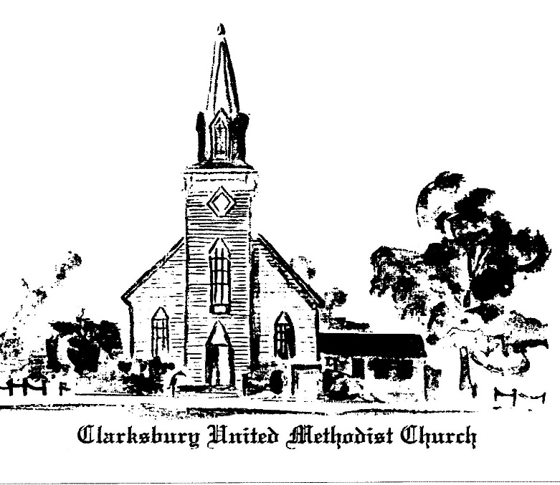

15924 General Puller Hwy.
P.O. Box 10
Hardyville, VA 23070
(804) 776-6060
www.clarksburyumc.com

Our Mission
To receive and share God’s love through
worship, education, service, and outreach

June 11, 2023
2nd Sunday after Pentecost
(As we gather, let us do so in reverent silence.)

Chimes

Prelude Ann Thomas
“Fanfare on the Solid Rock”, arr. Wilson

Greeting & Announcements

VCall to Worship: Psalm 33:1-12 UMH 767
(w/Choral Response #2)

Affirmation of Faith: Wesleyan Covenant Prayer UMH 607

VGloria Patri UMH 70

VHymn of Praise UMH 96
“Praise the Lord Who Reigns Above”
(Please pass your praise & concern cards to the ushers during the last verse.)

Prayer Concerns and Pastoral Prayer

The Lord’s Prayer

Anthem Chancel Choir
“Every Day Is a Gift from the Lord” - Don Besig, Nancy Price

New Testament Reading: Romans 4:13-25 Page 155

Children’s Sermon

Sermon “Righteousness of Faith” Pastor Ken

VHymn of Invitation UMH 508
“Faith, While Trees Are Still in Blossom”

Offering Becky Wilhite
“My Faith Looks Up to Thee”, arr. William Stickles

Doxology UMH 95

Praise God, from whom all blessings flow;
praise Him, all creatures here below;

praise Him above, all heavenly host;
praise Father, Son, and Holy Ghost. Amen.

Offertory Prayer

VHymn of Dedication “Standing on the Promises” UMH 374

 Benediction

Choral Benediction “We Walk by Faith” TFWS 2196

V Chimes

Postlude

V Please stand as you are able.

Church Copyright License ® A 21853196
Streaming Plus License ™ A 21853206

Scripture Reader/ Liturgist for June: Linda Bartz
Counters for June: Betty Farmer & Don Bartz
Ushers for June: Betty Farmer & Becky Foster

