Prayer Concerns

Carl and Betty Tate; Kim and Ann South;; Isla Escagne; Sue Bueakenkamp; Kathy Carraway; Fred & Jerry Dant; Sandy Springs, Emily Farmer’s friend; Betty Johnson; Marina Schofield; Jim and Sue Ann Salmon; Connie & Johnnie Robertson; Rev. Gary Livermon; Peggy Vaudt; Phil & Joyce Smith; Trisha, Wandra Thornton’s friend; Steve Davis; Teresa Keaton; Candi, Betty Ann Tabler’s niece; Chip Britzmayr; Fran Miller’s cousin; Betty Ann Tabler; Dolores Decker’s neighbors, on death of daughter; all those recovering from covid and other illnesses

Calendar

Tuesday Church Council 7:00 p.m.
Thursday Chancel Choir 11:00 a.m.
Saturday Contemporary Worship 5:00 p.m.
Sunday Adult Sunday School 10:00 a.m.

Announcements

Bake Sale- The women and men of Clarksbury will hold a bake sale on Saturday, May 27th from 9 a.m. till noon. Please begin to bake your favorite items, breads, cakes, pies, pastries, and more. The money will go to our operating funds.

The Called Charge Conference for the disaffiliation vote will be held on Saturday, June 24th at 1 p.m. Please note, only professing members of Clarksbury UMC are eligible to vote and must be present at this meeting to vote. No proxies or absentee ballots.

Scholarship - It is that time of year again! If you have a family member continuing their higher education, they are eligible to receive the church’s scholarship. Applications are on the church website. Applications must be received by June 15.

We give a warm welcome to our guests today. Please stop by the fellowship hall for refreshments after church.

Scripture for May 21:
Acts 1:1-11

Clarksbury
United Methodist Church

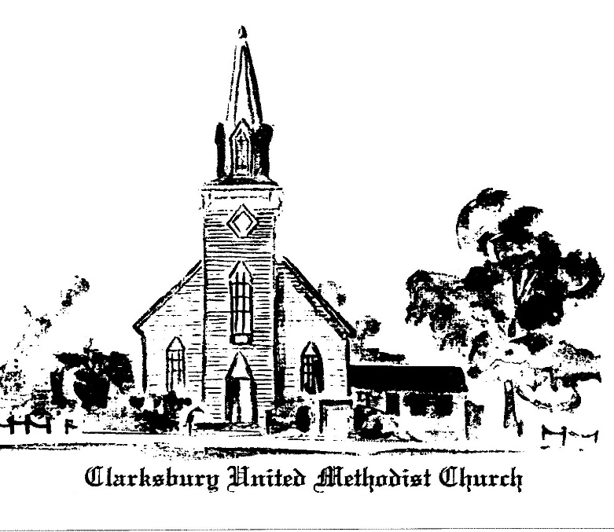,6
oooooooooooooooooooooooooooooooooooooo

15924 General Puller Hwy.
P.O. Box 10
Hardyville, VA 23070
(804) 776-6060
www.clarksburyumc.com

Our Mission
To receive and share God’s love through
worship, education, service, and outreach

May 14, 2023
6th Sunday of Easter
Mother’s Day
(As we gather, let us do so in reverent silence.)

Chimes

Prelude

Greeting & Announcements

VCall to Worship: Psalm 66:8-20 UMH790

VAffirmation of Faith: Apostles’ Creed UMH 881

VGloria Patri UMH 70

VHymn of Praise UMH 445
“Happy the Home When God is There”
(Please pass your praise and concern cards to the ushers during the last verse.)

Prayer Concerns and Pastoral Prayer

The Lord’s Prayer

Anthem Chancel Choir
"With a Joyful Song” N. Price & D. Besig

New Testament Reading: 1 Peter 3:13-22 Page 234

Children’s Sermon

Sermon “Made Alive in the Spirit” Pastor Ken

VHymn of Invitation “Loving Spirit” TFWS 2123

Offering

Doxology UMH 95

Praise God, from whom all blessings flow;
praise Him, all creatures here below;
praise Him above, all heavenly host;
praise Father, Son, and Holy Ghost. Amen.

Offertory Prayer

VHymn of Dedication “To God Be the Glory” UMH 98

 Benediction

V Chimes

Postlude

V Please stand as you are able.

Church Copyright License ® A 21853196
Streaming Plus License ™ A 21853206

Financial Standings:
2023 Operating Budget $ 118,440.00
Received as of May 7: $ 44,218.93
Needed by end of May to stay on budget $ 5,131.07

Scripture Reader/ Liturgist for May: Linda Dobbins
Counters for May: Warren Wright & Linda Dobbins
Ushers for May: Alan Miller & Betty Chenowith

Pastor Ken Cleveland
776-1177 Home kencleveland@vaumc.org (276) 224-4935 Cell Pastor’s Office Hours:
Tuesday 9 – 11 AM; Thursday 1 – 3 PM
Ministers of Music Becky Wilhite, Ann Thomas
Nursery Kimberly South
Custodian Ilka Fernandez
Ministers People of Clarksbury

