Prayer Concerns

Carl and Betty Tate; Kim and Ann South;; Isla Escagne; Sue Bueakenkamp; Kathy Carraway; Fred & Jerry Dant; Sandy Springs, Emily Farmer’s friend; Betty Johnson; Marina Schofield; Jim and Sue Ann Salmon; Connie & Johnnie Robertson; Rev. Gary Livermon; Peggy Vaudt; Phil & Joyce Smith; Trisha, Wandra Thornton’s friend; Steve Davis; Teresa Keaton; Candi, Betty Ann Tabler’s niece; Chip Britzmayr; Fran Miller’s cousin; Betty Ann Tabler; the family of Vicky Hogge; Garland Dobbins; Dolores Decker’s neighbors, on death of daughter; all those recovering from covid and other illnesses

Calendar

Thursday Chancel Choir 11:00 a.m.
Saturday Mother’s Day Breakfast 9:00 a.m.
Saturday Contemporary Worship 5:00 p.m.
Sunday Adult Sunday School 10:00 a.m.

Announcements

The Called Charge Conference for the disaffiliation vote will be held on Saturday, June 24th at 1 p.m. Please note, only professing members of Clarksbury UMC are eligible to vote and must be present at this meeting to vote. No proxies or absentee ballots.

Scholarship - It is that time of year again! If you have a family member continuing their higher education, they are eligible to receive the church’s scholarship. Applications are on the church website. Applications must be received by June 15.

We give a warm welcome to our guests today. Please stop by the fellowship hall for refreshments after church.

Scripture for May 14:
1 Peter 3:13-22

Financial Standings:
2023 Operating Budget $ 118,440.00
Received as of April 30: $ 41,370.82
Needed by end of May to stay on budget $ 7,979.18
Scripture Reader/ Liturgist for May: Linda Dobbins
Counters for May: Warren Wright & Linda Dobbins
Ushers for May: Alan Miller & Betty Chenowith

Clarksbury
United Methodist Church

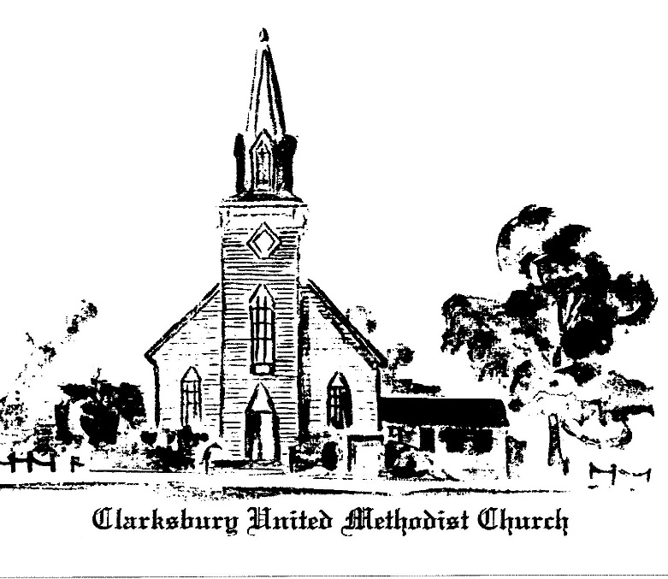

15924 General Puller Hwy.
P.O. Box 10
Hardyville, VA 23070
(804) 776-6060
www.clarksburyumc.com

Our Mission
To receive and share God’s love through
worship, education, service and outreach

May 7, 2023
5th Sunday of Easter
(As we gather, let us do so in reverent silence.)

Chimes

Prelude Ann Thomas

Greeting & Announcements

V Call to Worship: Psalm 31:1-5, 15-16 UMH 764

V Affirmation of Faith: Wesleyan Covenant UMH 607

Gloria Patri

VHymn of Praise UMH 154
“All Hail the Power of Jesus’ Name”
(Please pass your concern cards to the ushers during this time.)

Prayer Concerns and Prayer

Invitation to the Table
Christ our Lord invites to his table all who love him, who earnestly repent of their sin and seek to live in peace with one another. Therefore, let us confess our sin before God and one another.

Prayer of Confession
Merciful God, we confess that we have not loved you with our whole heart. We have failed to be an obedient church. We have not done your will, we have broken your law, we have rebelled against your love, we have not loved our neighbors, and we have not heard the cry of the needy. Forgive us, we pray. Free us for joyful obedience, through Jesus Christ our Lord. Amen. (All pray silently)

Declaration of Forgiveness
Hear the good news: Christ died for us while we were yet sinners; that proves God’s love toward us. In the name of
Jesus Christ, you are forgiven.
In the name of Jesus Christ, you are forgiven! Glory to God.
Amen.

Anthem Chancel Choir
"Wonderful, Merciful Savior” D. Rogers & E. Wyse

New Testament Reading: Acts 7:55-60 Page 126

Children’s Sermon

Sermon: “Sacrifice & Witness” Pastor Ken

VHymn of Invitation “Be Still, My Soul” UMH 534

Offering (Please put any visitors cards in the offering plate)
Doxology UMH 95
Praise God, from Whom all blessings flow;
praise Him, all creatures here below;
praise Him above all heavenly host;
praise Father, Son, and Holy Ghost. Amen.
Offertory Prayer

Service of Word and Table See Insert

VHymn of Dedication UMH 580
“Lead On, O King Eternal"

 Benediction

V Chimes

Postlude

V Please stand as you are able

Church Copyright License ® A 21853196
Streaming Plus License ™ A 21853206

Pastor Ken Cleveland
776-1177 Home kencleveland@vaumc.org (276) 224-4935 Cell Pastor’s Office Hours:
Tuesday 9 – 11 AM; Thursday 1 – 3 PM
Ministers of Music Becky Wilhite, Ann Thomas
Nursery Kimberly South
Custodian Ilka Fernandez
Ministers People of Clarksbury

