Prayer Concerns

Carl and Betty Tate; Kim and Ann South; Isla Edwards; Kathy Carraway; Fred & Jerry Dant; Sandy Springs, Emily Farmer’s friend; Betty Johnson; Marina Schofield; Jim and Sue Ann Salmon; Connie & Johnnie Robertson; Peggy Vaudt; Phil & Joyce Smith; Trisha, Wandra Thornton’s friend; Steve Davis; Theresa Keeton; Betty Ann Tabler and her niece, Candi; Chip Britzmayr, Fran Miller’s cousin; Richard Sisson's friend; Jim Chenowith, Jr.; Barry Jett; Kent Swanson; Kathy Snow; Linda Cole; Betty Farmer; Bill Will; Bill Green; Harry Caraway; Mark Williamson; Nic Hayes; Garland Dobbins; Jody Barnes, nephew of Warren & Kathy; Lucy Blevins; Lynn McMurtrie; Peyton Arthur; all those recovering from covid and other illnesses

Calendar

Tuesday Chancel Choir 11:00 a.m. Saturday Contemporary Worship 5:00 p.m.
Sunday Adult Sunday School 9:45 a.m.

Announcements

On Friday, October 27 from 4-6 p.m., the men and women of Clarksbury Church will have a takeout only barbeque dinner. Tickets are $15 and will be available from the men of the church or at the door.

On Saturday, October 28, Zoar will be having their annual Trunk or Treat. We will be collecting candy today and next Sunday. If you can help, please bring pre-packaged individual candies. Thank you.

We give a warm welcome to our guests today. Please stop by the fellowship hall for refreshments after church.

Financial Standings:
2023 Operating Budget $ 118,440.00
Received as of October 1: $ 101,080.06
Needed by end of October to stay on budget - $ 2,380.06

Scripture for October 15:
Matthew 22:1-14

Clarksbury
United Methodist Church

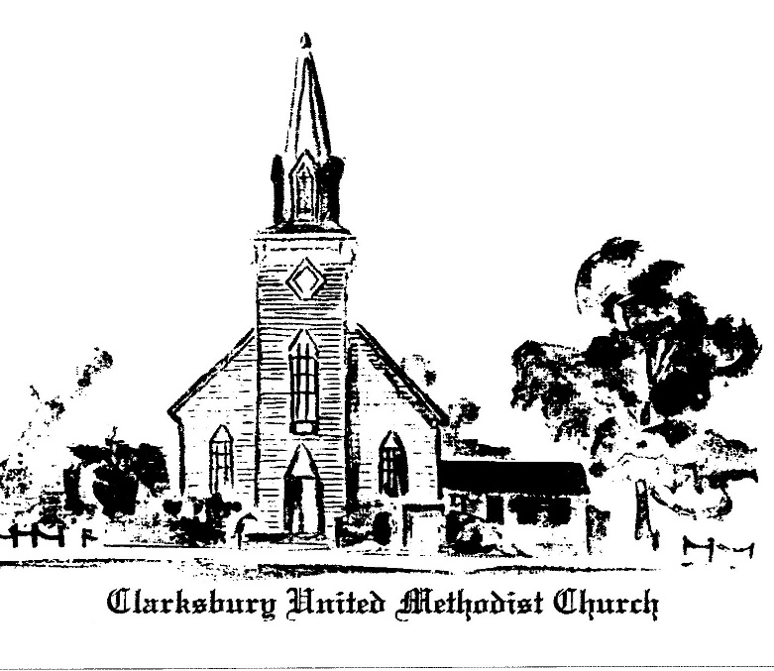

15924 General Puller Hwy.
P.O. Box 10
Hardyville, VA 23070
(804) 776-6060
www.clarksburyumc.com

Our Mission
To receive and share God’s love through
worship, education, service, and outreach

October 8, 2023
19th Sunday After Pentecost
(As we gather, let us do so in reverent silence.)

Chimes

Prelude Becky Wilhite
“I'll Walk with God” Nicholas Brodszk

Greeting & Announcements

V Call to Worship: Psalm 9:1-14 UMH 750

V Affirmation of Faith: Wesleyan Covenant UMH 607

Gloria Patri

VHymn of Praise UMH 545
“The Church's One Foundation”
(Please pass your concern cards to the ushers during this time.)

Prayer Concerns and Pastoral Prayer

The Lord’s Prayer

Anthem Chancel Choir
“In Christ Alone” arr. Travis Cottrell

New Testament Reading: Matthew 21:33-46 Page 24

Children’s Sermon

Sermon “People Who Produce Fruit” Pastor Ken

VHymn of Invitation UMH 529
Liturgist for October: Warren Wright
Counters for October: Charles Townes & John Hooper
Ushers for October: John & Pat Hooper

“How Firm a Foundation”

Offering Becky Wilhite
“You Do As Unto Me” Ken Dosso

Doxology UMH 95
Praise God, from Whom all blessings flow;
praise Him, all creatures here below;

praise Him above all heavenly host;
praise Father, Son, and Holy Ghost. Amen.

Offertory Prayer

VHymn of Dedication TFWS 2220
"We Are God's People"

 Benediction

V Chimes

Postlude Becky Wilhite
“The Promised Land” - traditional spiritual

V Please stand as you are able

Church Copyright License ® A 21853196
Streaming Plus License ™ A 21853206
Pastor Ken Cleveland
(804) 776-1177 Home kencleveland@vaumc.org (276) 224-4935 Cell Pastor’s Office Hours:
Tuesday 9 – 11 a.m.; Thursday 1 – 3 p.m.
Ministers of Music Becky Wilhite, Ann Thomas
Nursery Kimberly South
Custodian Ilka Fernandez
Ministers People of Clarksbury

Counters for September: Polly VanBenschoten & Cacky Guill
Ushers for September: Diane Faulkner & Cacky Guill

